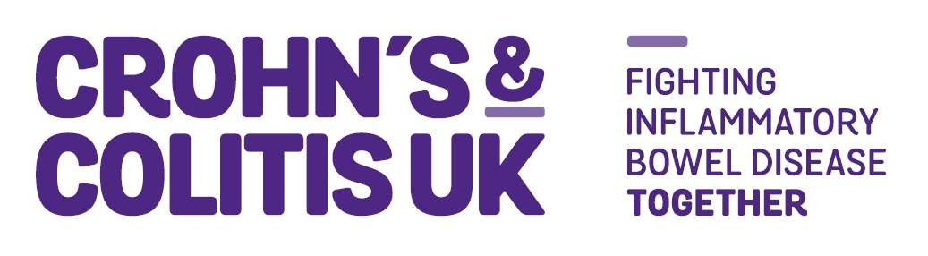Volunteer Application Form

[Local Network - Awareness & Activities]

Crohn’s & Colitis UK works with all those affected by Crohn’s and Colitis to achieve a better quality of life, improve support services and, ultimately, find a cure.

Your Local Network:

Contact Details
Surname: |  | First Names:
Address:

If you are under 18 years old please provide your date of birth:
Telephone (Day time): |  | Telephone (Evenings):
Email address: |  | Mobile:
Application Information
For how long are you looking to volunteer?
<3 MONTHS 3-6 MONTHS 7-12 MONTHS INDEFINITELY UNKNOWN

Are you a Crohn’s & Colitis UK member? | Yes Membership Number:  No
How did you hear about this role?
Crohn’s & Colitis UK Website Volunteer Centre Do-it.org Team London
Other - please specify__________________________________________________
Please tell us what you know about Crohn’s & Colitis UK. e.g. where and how we work, who we help and what we do etc.

Please tell us why you would like to volunteer in this position. e.g. share your skills, boost confidence, gain experience, meet new people etc.

Please tell us what skills and experiences make you the right person for this role. Please see the role profile, required abilities and person specification to complete this section.

Is there any other information that you feel would be relevant?

Equal Opportunities
If you have any access requirement or health issues which we should be aware of, please state them here: (All roles may include physical tasks, e.g. manual handling, use of stairs, repetitive tasks etc)

Declaration
I hereby apply to become a volunteer with Crohn’s & Colitis UK. Should I be successful in my application, I agree to adhere to all Crohn’s & Colitis UK practices, procedures, guidelines and policies - keeping to the principles of volunteering outlined in the Crohn’s & Colitis UK’s Volunteer Policy. I agree that Crohn’s & Colitis UK may hold and use the data on this form for the purposes of administering and supervising my work with the charity.

I declare the information I have provided is a true and accurate record.
Print Name: |  | Dated:
At Crohn’s & Colitis UK, we take your privacy seriously. We will use your personal information to keep in touch with you about your volunteering.
If you agree, we would also like to get in touch with you with news and updates of other ways you can make a difference to those affected by Crohn’s and Colitis. Please tick below to let us know how you’d like us to send you our news and updates:

Post email telephone

I do not wish to receive news & updates in the future

For full details of how we use and protect personal data go to our Website

Please return this form to: volunteering@crohnsandcolitis.org.uk or by post to: Crohn’s & Colitis UK, 1 Bishops Square, Hatfield Business Park, AL10 9NE

Please include the title of the volunteer role you are applying for in the “subject” of your email.

