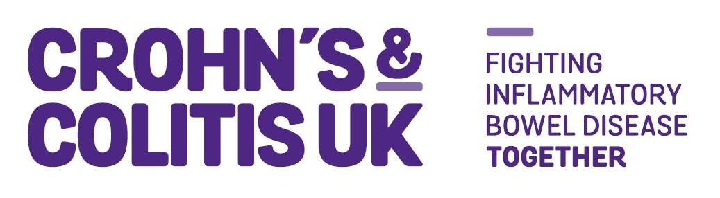Volunteer Application Form

[Local Network - Awareness & Activities]

Crohn’s & Colitis UK is here to give people affected by Crohn's and Colitis hope, comfort and confidence. To make sure their voices are heard and help them live freer, fuller lives. For whatever they need, whenever they need it, we’re here. And we’re not going anywhere until we’ve beaten Crohn’s and Colitis for good.

Your Local Network:

Contact Details
First Names: |  | Surname:
Address:

If you are under 18 years old please provide your date of birth:
Telephone (Day time): |  | Telephone (Evenings):
Email address: |  | Mobile:
Application Information
For how long are you looking to volunteer?
☐ <6 MONTHS ☐ 7-12 MONTHS ☐ 1-2 YEARS ☐ INDEFINITELY ☐ UNKNOWN

Are you a Crohn’s & Colitis UK member? | ☐ Yes Membership Number:  ☐ No
How did you hear about this role?
☐ Crohn’s & Colitis UK Website ☐ Volunteer Centre ☐ Do-it.org
☐ Other - please specify__________________________________________________
T-shirt size required. Once in the role you’ll be provided with a purple Crohn’s & Colitis UK t-shirt.

☐ Small ☐ Medium ☐ Large ☐ X Large ☐ XX Large ☐ Not required (already have one)

Please tell us what you know about Crohn’s & Colitis UK. e.g. where and how we work, who we help and what we do etc.

Please tell us why you would like to volunteer in this position. e.g. share your skills, boost confidence, gain experience, meet new people etc.

Please tell us what skills and experiences make you the right person for this role. Please see the role profile, required abilities and person specification to complete this section.

Please tell us of any other skills and experiences you have that are relevant to the role

Equal Opportunities
If you have any access requirements or health issues you would wish to share with us please state them here:

Declaration
I hereby apply to become a volunteer with Crohn’s & Colitis UK. I commit to upholding the reputation of Crohn’s & Colitis UK and will familiarise myself with and adhere to any guidance provided.

I declare the information I have provided is a true and accurate record.
Print Name: |  | Dated:
Privacy
At Crohn’s & Colitis UK, we take your privacy seriously. We will use your personal information to keep in touch with you about your volunteering. This will include sharing your contact details with other volunteers in the Local Network to enable you to fulfil this role.

If you agree, we would also like to get in touch with you with news and updates of other ways you can make a difference to those affected by Crohn’s and Colitis. Please tick below to let us know how you’d like us to send you our news and updates:
☐ Post ☐ Email ☐ Telephone

☐ I do not wish to receive news & updates in the future

For full details of how we use and protect personal data go to our Website

Please return this form to: volunteering@crohnsandcolitis.org.uk or by post to: Crohn’s & Colitis UK, 1 Bishops Square, Hatfield Business Park, AL10 9NE

Please include the title of the volunteer role you are applying for in the “subject” of your email.

Part B – Equality, Diversity and Inclusion Monitoring
Crohn’s & Colitis UK always treats your personal details with great care and we keep your information safe. We only hold information for communication, analysis and administrative purposes, and our full privacy notice explains what we do, and how we control your personal information.

We know that some types of personal details are more sensitive. We only request this information to support our work when there is a clear reason for this. For example, to make improvements to our patient information, or to better inform our work.

Sharing this information with us is optional and you can have this data removed from our records at any time.
What is your date of birth?
__/__/___

Which of the following best describes your gender?
☐ Man
☐ Non-binary
☐ Woman
☐ Prefer to self-describe (please describe) ………………………………………………….
☐ Prefer not to say
What is your ethnic group? Choose one option that best describes your ethnic group or background.
Asian / Asian British
☐ Bangladeshi
☐ Chinese
☐ Indian
☐ Pakistani
☐ Any other Asian background, please describe ………………………………………………….

Black / African / Caribbean / Black British
☐ African
☐ Caribbean
☐ Any other Black / African / Caribbean background, please describe …………………………………………………
Mixed / Multiple ethnic groups
☐ Asian and White
☐ Black Caribbean and White
☐ Black African and White
☐ Any other Mixed / Multiple ethnic background, please describe ………………………………………………….

White
☐ English / Welsh / Scottish / Northern Irish / British
☐ Gypsy or Irish Traveller
☐ Irish
☐ Any other White background, please describe ………………………………………………….

Any other ethnic group
☐ Arab
☐ Any other ethnic group, please describe ………………………………………………….
What is your primary connection with Crohn’s Disease or Ulcerative Colitis?
☐ I have Crohn's Disease
☐ I have Ulcerative Colitis
☐ I have another form of Inflammatory Bowel Disease (IBD)
☐ I am a parent or carer of someone with Crohn's or Colitis
☐ I am a friend of someone with Crohn's or Colitis
☐ I am a relative of someone with Crohn's or Colitis
☐ I am a Healthcare Professional
☐ Other ………………………………………………….
Which of the following best describes your sexual orientation?
☐ Asexual
☐ Bi/bisexual
☐ Gay Man
☐ Gay Woman/Lesbian
☐ Pansexual
☐ Queer
☐ Straight/Heterosexual
☐ I identify in another way (please describe) ………………………………………………….
☐ Prefer not to say

Version: September 2024

